**Front-End UI/UX Mini Project**

**Project Submission Template**

**1. Title Page**

* **Project Title:** e.g., *Responsive Portfolio Website for a Freelancer*
* **Submitted By:**
  + **Team Members:** Neha Tresa Boby

Tania Robby

* + **Roll Number(s):** 2460411

2461032

* + **College Email ID:** [**neha.tresa@btech.christuniversity.in**](mailto:neha.tresa@btech.christuniversity.in)

[**tania.robby@btech.christuniversity.in**](mailto:tania.robby@btech.christuniversity.in)

* **Course:** *UI/UX Design Fundamentals*
* **Instructor Name:** Mr. Narendra Kumar
* **Institution:** *CHRIST (DEEMED TO BE UNIVERSITY )*
* **Date of Submission:** 11/08/2025

**2. Abstract**

This project focuses on designing and developing a responsive website for Veritas Lumina University's Computer Science department. The primary goal was to create an informative and user-friendly online presence that showcases key information about the department's faculty, course offerings, and research areas. The project was built using HTML for structure and CSS for styling, with a strong emphasis on a clean, modern aesthetic and intuitive navigation. A key feature is the inclusion of interactive elements like expandable accordions for faculty details and a hover animation for the heading. The final outcome is a well-organized and visually appealing website that effectively serves as a central hub for prospective and current students to learn about the department's academic and research environment.

**3. Objectives**

* Design a user-friendly interface using modern UI principles.
* Develop a fully responsive layout using only HTML5 and CSS.
* Apply CSS styling for branding, layout, and responsiveness.
* Ensure accessibility and readability across devices.
* Use CSS-only interactivity, such as accordions and tables.
* Structure academic content in a formal yet approachable layout.

**4. Scope of the Project**

* Focused on front-end design only.
* No JavaScript or server-side integration was used.
* The project was intended for desktop, tablet, and mobile viewports.
* Only open-source tools and pure code were used.

**5. Tools & Technologies Used**

| **Tool/Technology** | **Purpose** |
| --- | --- |
| HTML5 | Markup and content structure |
| CSS3 | Styling and layout management |
| VS Code | Code editor |
| Chrome DevTools | Testing and debugging |

**6. HTML Structure Overview**

The page is built with a standard HTML5 structure, starting with a <head> containing metadata and a link to the CSS file. The main content is housed within the <body>, which is divided into a header and several section elements.

* **<header>**: The <header> element is for branding, featuring a university logo, name, slogan, and the department title.
* **Navigation**: A <div> with the class .side-nav serves as a navigation menu, using an unordered list (<ul>) and links (<a>) to enable smooth scrolling to different page sections.
* **Content Sections:** The core content is separated into three distinct <section> tags, each with a unique ID:
  + **#faculty-spotlight:** This section presents faculty information using a CSS-only accordion. Each faculty member's details are hidden until the user clicks on their name.
  + **#course-catalog:** This section displays a list of courses in a standard <table> format, complete with a header and rows of course data.
  + **#research-areas:** This section uses a CSS grid to lay out blocks of text, each representing a different research focus.

**7. CSS**

* Used an external CSS file: style.css.
* Organized with comments and sections.
* Techniques used:
  + Flexbox for header and content alignment.
  + Grid for the research areas section.
  + @media queries for responsive design.
  + Hover effects with transition for smooth animations on links, accordions, and table rows.
  + Pseudo-elements (::after, ::before) for decorative underlines.
  + Styling for accordion-style content to show/hide details.

**8. Key Features**

|  |  |  |  |
| --- | --- | --- | --- |
| **Feature** | **Description** |  |  |
| Responsive Design | Adapts seamlessly to all screen sizes |  |  |
| Smooth Navigation | Fixed top navigation with anchor links |  |  |
| Project Cards | Flex-based layout with hover effects |  |  |
| Contact Form (non-functional) | Placeholder layout for inputs and button |  |  |
| Accessible Fonts & Colors | High contrast and readable typography |  |  |

**9. Challenges Faced & Solutions**

|  |  |  |  |
| --- | --- | --- | --- |
| **Challenge** | **Solution** |  |  |
| **Maintaining consistent spacing** | Utilised CSS properties like margin and padding to control spacing between elements. |  |  |
| **Creating interactive elements without JS** | Implemented a CSS-only accordion using input[type="checkbox"] and the + sibling selector. |  |  |
| **Ensuring smooth visual effects** | Used transition properties on various elements to animate changes in transform, width, and background-colour. |  |  |

**10. Outcome**

A clean, consistent, and visually engaging front-end layout was successfully achieved. All key components function as intended using only HTML and CSS, demonstrating a strong understanding of fundamental web design principles. The project resulted in a well-organised and informative website, effectively serving as a functional prototype for the university department.

**11. Future Enhancements**

* Add JavaScript for interactivity, such as form validation or dynamic content loading.
* Integrate a light/dark mode theme toggler.
* Add a backend for content management and form submissions.
* Optimise performance for faster loading times

**12. Sample Code – Code Snippets**

* **HTML - Header & Branding**

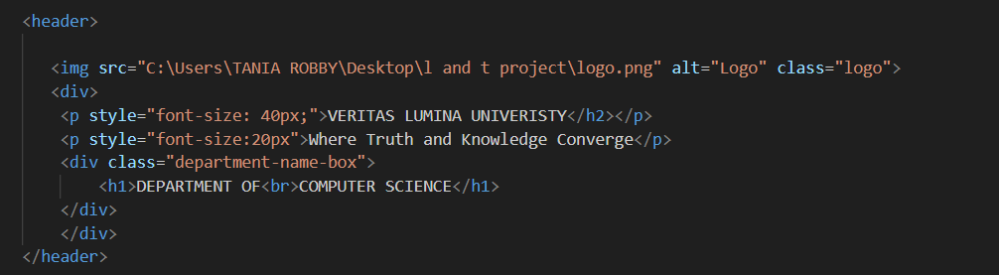

* **HTML – Side Navigation**

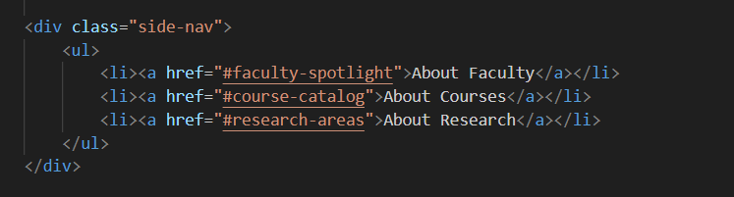

* **HTML – Research Area Grid**

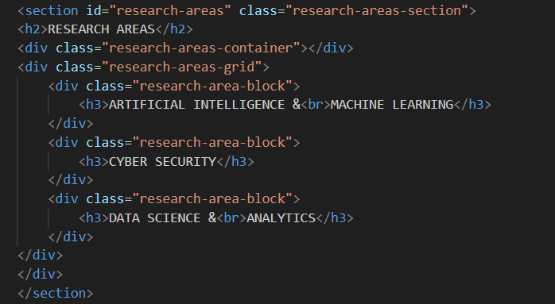

* **CSS – Accordian**

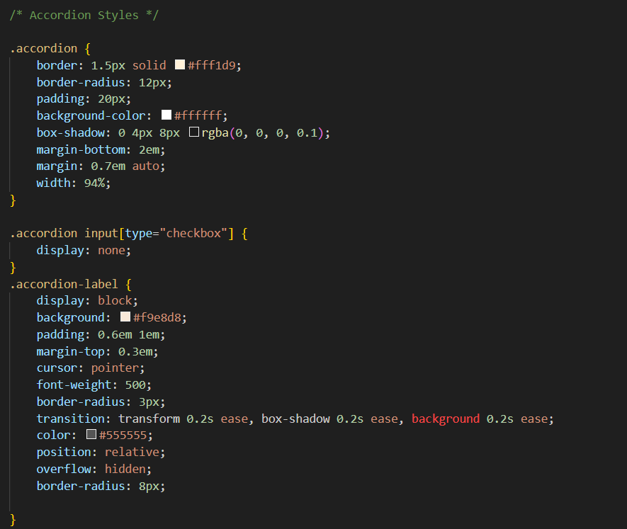

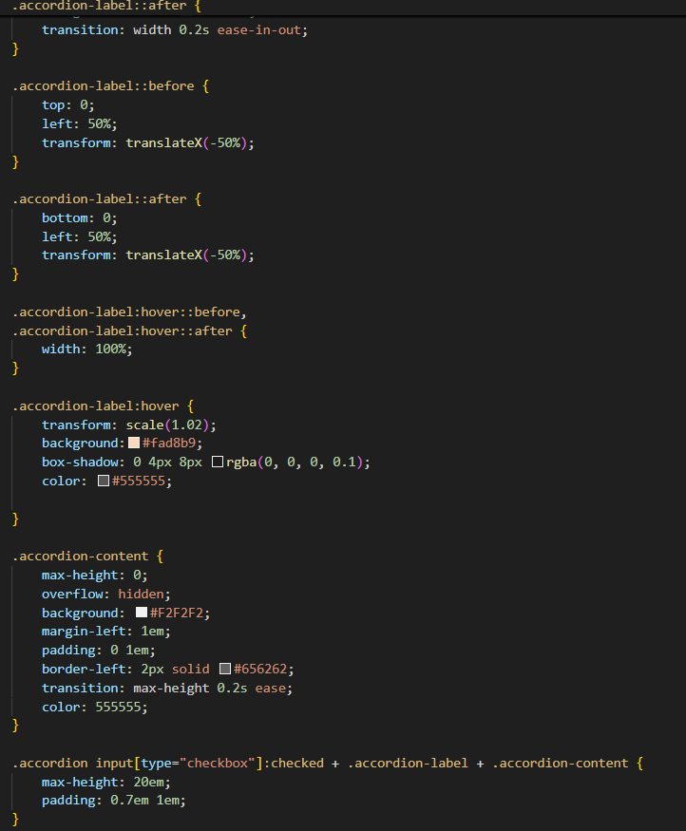

* **CSS – Table**

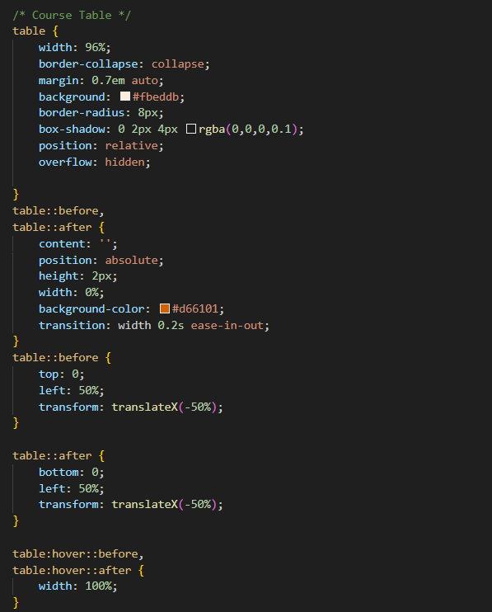

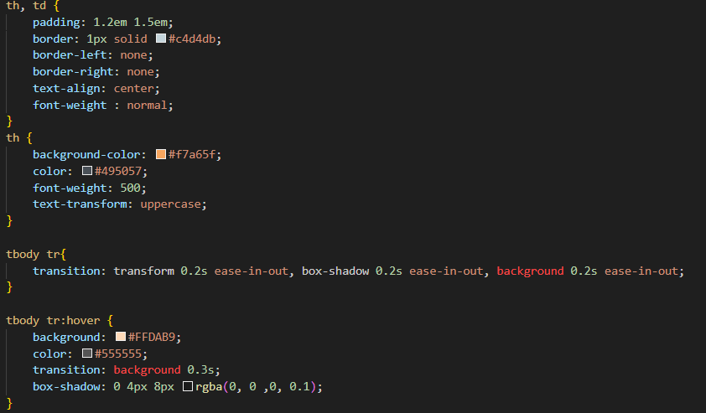

* **CSS – Header Styling**

